
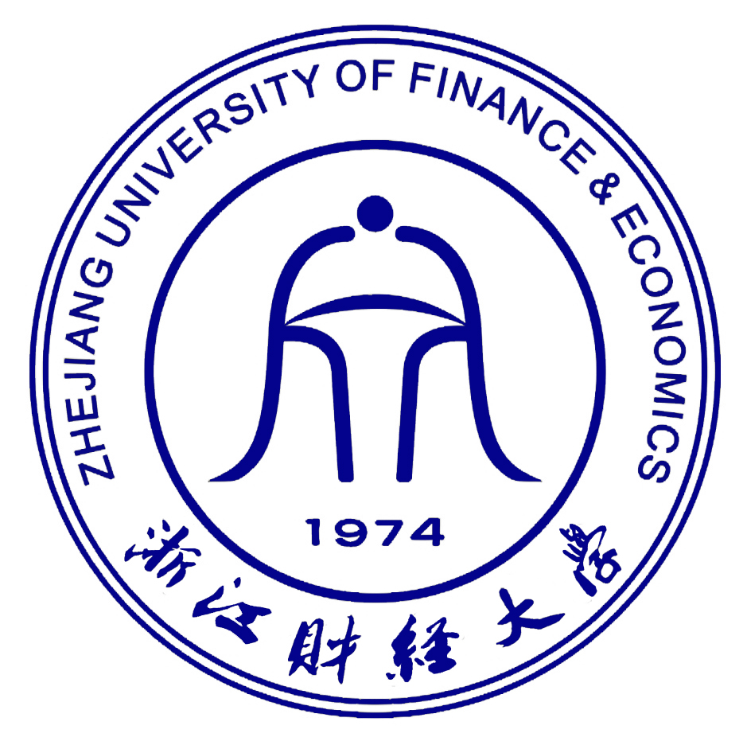
Thesis Proposal

Title： International Online Marketing to China:
How Live Streaming is influencing buying behaviour

Name: Polyakov Vyacheslav
ID number: 172023010168
Supervisor: 赵卓嘉
School: International School
Major: International Economics and Trade
Year: 2017

Date: 12/02/2020
- 论文（设计）选题的依据（选题的目的和意义、该选题国内外的研究现状及发展趋势等）The basis of the research (the purpose and significance of the research, Research status and development trend at home and abroad etc.):

The aim of this social investigation is to identify and measure the influence of promoting a business through online media channels on the consumers’ buying behaviour. Since Weibo is an open platform that has been used for mass marketing more than any other Chinese social media, it has been chosen as the most accurate example of how businesses can utilize online marketing in China. Unlike other social media such as Douyin that is gaining in popularity or WeChat that has recently introduced the video channels functionality, Weibo provides exactly what the marketers need: audiences that are used to watching long videos. We know that marketing campaigns work the best on the loyal audiences that are the most engaged with the key opinion leaders.
“Different from WeChat, Weibo is an open social platform, ideal for mass marketing. That's why it is also one of the most important platforms for KOL marketing. Almost all the celebrities and KOLs you could possibly name in China have their official account on Weibo.” - seochina.com

In the modern world, both in my home country and abroad, social media has proven to be an extremely potent platform for marketing. According to a 2018 survey by Marketing and Sociological Research Institute “Elim”, social network applications have already become the most effective advertisement tool among people in Kazakhstan, with Instagram being the most popular one (36.2%). The other major platforms used by Kazakhstani people are WhatsApp (15.2%) and Facebook (14.8%), while only 10.2% of respondents stated that they don’t use social media at all, which proves its widespread influence inside the country. Hence the technological advancement and the gradual shift that occurred in the society from receiving the most information by watching television and reading newspapers to consuming most content online, the research on the topic of digital marketing is experiencing a rising trend in the last few years.

As for the research papers written in English, the world has to offer a plenty of literature on the subject of social media, however the marketing opportunities presented by the phenomenon are still in the beginning of being thoroughly investigated. A comprehensive study by Information System Frontiers, a journal of research and innovation, gives an overview of the development of social media studies. A total of 132 articles from the Web of Science database were analyzed in their paper “Advances in Social Media Research: Past, Present and Future”. The study revealed that while among the reviewed articles were papers researching various topics related to social media, only “around 13 publications studied the use of social media as a marketing tool”.

Nevertheless, with more and more businesses integrating into the digital environment, a lot more research on the topic has been done recently. This is especially true in the Chinese market: since so many essential services, such as payment, shopping, ordering food, and even laundry have been digitized, it has become easier to use internet applications for promotion. Even though most of the outside world’s online applications, such as Google, YouTube, Facebook, Instagram, Twitter are all blocked in China due to censorship, popularity of the domestic social media platforms are on the rise, which, combined with the foreign businesses interest in the Chinese market due to the rising economy, serves as a terrific opportunity for more research on the topic of digital marketing.

It is hoped that at the end of the investigation there will be a clear indication of the potential of Chinese social media channels (Weibo in particular) in assisting both local and foreign businesses, that are planning to penetrate the Chinese market, in promotion, as well as statistical identification of what kind of target audience this marketing campaign would be the most suitable for and what kind of tactics would be the most effective. This study also aims to provide a foundation for further academic research in the field of international online marketing.

- 论文（设计）的主要研究内容及预期目标Research contents and expected objectives:

- Introduction
- Research background and significance
- Overview of social media marketing in China
- Summary of the literature previously written on the topic of social media marketing
- Defining social media and explaining the concepts that makeup its foundations
- Exploring the impact of a company’s integration of social media on consumer behavior
- Research status
A. Weibo As A Social Media Is The New Age Platform For Foreign Businesses to Market Their Products in China.
a. Online media is more potent than the rest of the media vehicle in influencing buying behavior.
b. Live streaming is more potent in influencing buying behavior than all other online marketing strategies.
c. Taobao Live is more potent in influencing buying behavior than all other live streaming platforms.
B. Live Streaming Is Potent In Influencing Consumer Behavior Only To The Younger Generation.
a. It is only the young adults and teenagers who could be influenced by marketing through Weibo.
IV. Methodology
A. Primary research - survey conducted among Chinese social media users
a. Designing an insightful survey
b. Analyzing the sample
c. Collation of data
d. Econometric regression model
B. The outcomes of the quantitative regression
V. Conclusions and suggestions
A. Analyzing the results and assessing significance of the outcome
B. Summarizing the objectives of the study on social media as a marketing tool
C. Findings and their implications in the international marketing

The main objectives of this study is to analyze Weibo as an online marketing tool for Chinese consumers, compare it to different approaches to advertising including the other local social media platforms and assess the degree of influence it has on buying behaviour in China. Furthermore the research aims to identify the key consumer age groups that marketing in Weibo can target.
Considering the popularity and the functionality of the online platform, the results are expected to be in the favour of Weibo providing a different environment for marketing as well as being one of the most potent social media platforms in terms of affecting consumers’ buying behaviour in China and completely outrunning the rest of the media vehicle.
- 论文（设计）的主要研究方案（拟采用的研究方法、准备工作情况及主要措施）Research plan (research methods, preparation and measures):

The primary research methods for this study are survey and linear regression analysis. First, an online questionnaire will be designed and suggested to people of different age groups in China. Secondly, the sample will be analyzed by its size and based on the personal information of the individual respondents. Next, the data retrieved from the responds will be compared between different groups of respondents. That will show whether or not Weibo provides a different environment for online advertising, and surpasses the other media vehicles as well as its rival social media platforms. Finally, a linear regression model will be built to find the correlation between the age of the respondents and the significance of social media influence on their buying behaviour.

The survey is planned to be conducted on Wenjuan (www.wenjuan.com), a Chinese commercial online survey service provider, with advertisement disseminated via WeChat (www.wechat.com).
The questionnaire shell be designed with a simple purpose: to find out whether or not Chinese consumers are more influenced by Weibo as a marketing platform rather than by other media vehicles and what age groups are affected the most. Since the need for accurate quantitative data, the respondents will be provided with closed-ended questions, such as multiple choice and checkbox questions.
A variety of questions will be asked to measure the influence of the online marketing on the consumers, such as where do respondents get the most information about the products and how often to they make a purchase after being introduced to the product. Every respondent will be asked to provide information about their age at the end of the survey.

A population of at least 500 Chinese residents of different ages will be surveyed. The questionnaire will be aimed at the subject of general products and services, with no limitations to any specific industry.
四、主要参考文献Reference:

- Alessia Rezzano. “Analysis of Chinese consumers behaviour and social media communication: A focus on luxury fashion brands”

- Arianna De Zuani. ’Digital Marketing in China: An analysis of the social media strategy of Tod’s Group’

- Bampo, Mauro, Michael T. Ewing, Dineli R. Mather, David Stewart, and Mark Wallace. 2008. “The Effects of the Social Structure of Digital Networks on Viral Marketing Performance.”

- Cox, Shirley A. 2010. “Online Social Network Member Attitude Toward Online Advertising Formats.”

- Di Pietro, Loredana and Elenora Pantano. 2012. “An Empirical Investigation of Social Network Influence on Consumer Purchasing Decision: The Case of Facebook.”

- Ferguson, Rick. 2008. “Word of mouth and viral marketing: taking the temperature of the hottest trends in marketing.”

- Golan, Guy J. and Lior Zaidner. 2008. “Creative Strategies in Viral Advertising: An Application of Taylor’s Six-Segment Message Strategy Wheel.”

- Huiying Yu.“The effect of social media comment on Chinese consumers' attitude toward the brand”

- Information System Frontiers. “Advances in Social Media Research: Past, Present and Future”

- Liyu Hu, Kicki Ly. “Social media in China – a study of attitudes, behaviors and gender differences among Chinese students”

- Liwei Chen. ”The influence of social media on consumer behavior”

- Mangold, Glynn W., and David J. Faulds. 2009. “Social Media: The New Hybrid Element of the Promotion Mix.”

- Marketing and Sociological Research Institute “Elim”. “Advertising efficiency and popular social networks in Kazakhstan”

- Muñiz, Albert M. and Hope Jensen Schau. 2007. “Vigilante Marketing and Consumer Created Communications.”

- University of Rhode Island. “Social Media as a Marketing Tool: A Literature Review”

五、论文（设计）研究工作进展安排Progress and arrangement of the research:
This study will be conducted between January 2021 and March 2021.
All the relevant theory on the topic to support the research will be collected and organized before January 10.
The questionnaire will be designed and uploaded online before January 20.
The survey is planned to be conducted between January 20 to February 20.
The results will be assessed and recorded in the first draft before March 15.

六、指导老师意见Comments of supervisor:

指导老师签字Signature of supervisor:

月M: 日D: 年Y:
七、学院论文（设计）领导小组意见Comments of school:

学院（盖章）School’s seal:

月M: 日D: 年Y:
This form is in two copies which should be kept by International school and supervisor.

